Report on TMM 10 based PCBs
(Patrice Bertet, 16/09/05)

1) Introduction and general design

For all superconducting qubit experiments, it is necessary to control the impedance seen by the circuit as well as possible up to frequency which can reach 20-30GHz. For two distinct reasons : 1) we want to develop microwave transmission measurements. This requires to truly control the impedance of all the lines since we measure non-linear circuits. 2) More deeply maybe, the qubit behaviour directly depends on the impedance seen at microwave frequencies which should therefore be known as good as possible. This might also mean that we need to change philosophy in the design of our chips and be a little more aware of the true impedance presented by our idealized lumped elements to the qubit. In particular our “capacitors” would deserve much more attention ; our resistors also. At a certain point, we might also want to renounce dealing with lumped elements and go for distributed circuits which seem more reliable from a microwave engineering point of view.

One of the problems we face is the transition between the coax lines whose impedance is a well-controlled 50 ohms to our silicon chips. In order to improve this we are testing a design which is directly inspired from Rob Schoelkopf lab in Yale (cf [1] for more details) :
coax
Grounded CPW
on TMM10i
CPW on Si chip
SMP
connectors
Bonding
wires

2) PCB design

Substrate : The PCB is made in a material called TMM10i specially developed by Rogers to have a low loss tangent, a well-defined dielectric constant with little dependence on frequency. Its value is ε_{r}=9.8. This is well-suited to make connections with Silicon samples which have a dielectric constant of ε_{r}=11.9. In addition the dielectric constant should vary little with temperature (30ppm/C which gives less than 1% for a 270°C drop). See the properties of TMM10i in annex 1. (Be careful that another material called TMM10 also exists, but its dielectric constant is not isotropic so TMM10i should be used instead). One could also note very pragmatically that TMM10 is already used by other groups doing the same type of measurements as us (low-temperature high-frequency). For instance : C. Glattli in Paris, T. Klapwijk 3 floors upstairs. Main drawbacks : as a ceramic-based material, it is very brittle. It is also expencive ! (100 pounds for a 10*7 inches^2 panel)

PCB processing : We ordered one series of test PCBs from a UK-based company called Printech (contact : Mark Harper, mark.harper@pcll.co.uk). They did a good job for a short delay except that they request payment in advance which leads to administrative problems. They are also expencive (the test PCBs costed 530 pounds for a 10-day processing and delivery. Specify that the delivery should be done by regular mail else they charge 50 more pounds for DHL shipping ! The amount of gold plating also counts, 2.5 microns should be enough but bonding not tested yet). For those interested, specify that the gold plating should be done WITHOUT magnetic material sticking layer such as nickel …

Connectors : We bought the connectors from Rosenberger, represented in Holland by Erwin van Leeuwerden (e-mail erwin@rosenberger.nl). All the connectors can be bought in two versions : “smooth bore” means that the insertion and removal forces are low (you can do it by hand), “limited detent” means that they are much higher and you need a special tool. Up to now we decided to use limited detent on-chip connectors (the bullets are supposed to stay in more or less permanently), and smooth bore for the cables which have to be disconnected frequently. But this could be changed of course. For the on-chip connectors one should take the 19S102-40M E4, for the bullets (F/F SMP adaptors) the 19K101-K00 E4, and for the cables the 19S641-271 E4 (SB) or 19S601-271 E4 (LD).

Design of the test structures :

Figure 1 : design of a test 50 ohms coplanar waveguide.

As an example of the test structures that were designed, see figure 1. The gold-plated copper parts are shown in red. On the left and on the right, see the footprints for the surface-mount SMP connectors. The exact design of these footprints is very important for the proper operation of the PCB. We need to ask the engineers from Rosenberger to calculate a proper footprint adapted to the type of connector that is used, the material, the type of structure (contact : Thomas Schmidt T_Schmid@Rosenberger.de). They use a 3D simulator which we don’t have so we just trust them. Note the presence, all around the conductors, of little holes called vias which are very important. They connect the lateral ground planes around the central conductor to the ground plane lying below the PCB (the bottom is covered with gold-plated copper). This geometry helps confining the field and improving the transmission.
To test our design, we made a few different varieties of test structures in order to test different points :
- waveguide design : how 50 Ω is it ? we made 3 types of Coplanar Waveguides (CPWs) identical apart for the width of the central conductor. The “CPW1” structures are designed to be 50 Ω according to the design of the Rosenberger engineers. The “CPW1L” has a larger width by 50 μm, and “CPW1S” a smaller width also by 50μm. This should correspond to variations in impedance by \pm 2 Ω.
- Influence of the length : to discriminate between effects coming from the PCBs and from the connectors we made also the same waveguides but shorter. They are called “CPW2”
- Tapered structures : transitions between different waveguides widths. “CPW1T” is a test for this aspect.
- Turns : “CPW1Uturn” tests a 90° angle
- Influence of vias : “CPW1V”
- Finally, we also made waveguides with cutouts so that it should be possible to put samples inside and measure them. We made cutouts of different sizes : for samples of 3.5*3.5mm and others 6.4*3.5mm (to be checked though). The samples can be bonded to the waveguides. This could be useful to measure LC resonators or waveguide resonators for instance.

Test box : We made a brass test box to check if injecting microwave in the waveguides excites resonances in the box. Semi-rigid cables terminated with SMP connectors can be screwed in the box and the height was adjusted so that it allows proper connection to the waveguide. The box should be redone in OFHC Copper in order to be used in a fridge. Be aware that he thread of the cable connectors that are screwed in the box is a special one (10-48 UNS-2A, see Rosenberger catalog). We have the tool to make it (see SMP box) but not the workshop.

Soldering of the connectors : A crucial point is the soldering of the SMP connectors to the PCB. For this we used solder paste Sn62Pb36Ag. A thickness of 200 microns is recommended by Rosenberger. Up to now we simply deposited the connector on the solder paste and heated it with “hair dryer”. In the future we should use the hot air soldering setup that Raymond bought recently. Also we should make a copper stencil that could hold the connectors pressed against the PCB while we heat them. See P. de Groot for more info. Very important : at the end of the process, clean the PCB in ethanol + ultrasonic in order to remove the flux due to soldering ! else the dielectric constant will be changed…

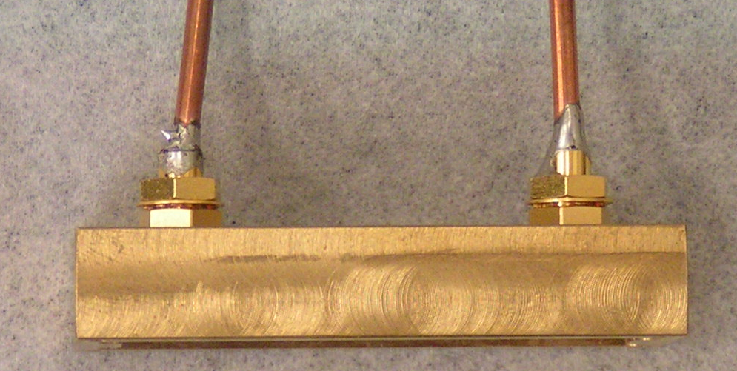
19S641-271 E4

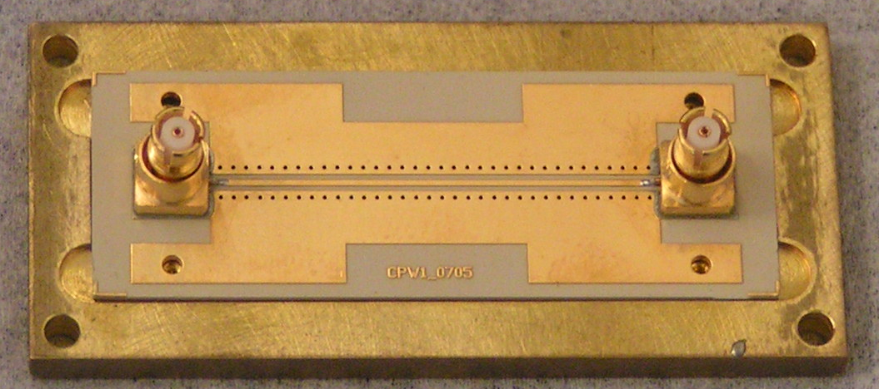
19S102-40M E4
19K101-K00 E4
2.7cm

3) Results of the measurements

Setup : We used the network analyzer (NA) from Nanofisica which makes measurements from 10MHz to 20GHz. We calibrated the NA using calibration kit (see Niels Hovenier for more details). Then we measured the transmission of the two SMA/SMP adaptors in series that we used for our measurements. We connected the PCBs through these two adapters and we substracted their contribution in all the measurements shown here.
We also used two cables with SMA connectors on one end and SMP on the other for the measurements inside the cavity called SRA and SRB. Due to a mistake in the measurements we unfortunately miss direct data for S21 from SRA and SRB. Nevertheless we could indirectly extract the sum of the two cables transmissions by substracting measurements of CPW1 transmission with and w/o the cables.

Measurements :
Figure 2 : S21 measurements of CPW1,1L,1S (solid line). Dashed : expected results given specified dielectric losses and Copper resistivity

Figure 3 : S11 measurements of CPW1,1L,1S (solid line)

We only measured the “CPW1” structures up to now ; other test structures corresponding to points 2-6 in the list above could be measured as well. Measurements of S21 are shown in figure 2 for the CPW1 structures in solid lines ; S11 is shown in figure 3. The three curves look very similar, all giving transmission through the PCB (S21 coefficient) until 20GHz with less than 2dB loss which is already a good point. Nevertheless, for all structures, we also see 1dB oscillation of S21 with a 1.85GHz period. This period is obviously related to the length of the waveguide : assuming an effective dielectric constant of ε_{reff}= (ε_{r}+1)/2=5.4, the frequency of a λ/2 resonator corresponding to the length of the structure L=27.5mm would be $ν=c/2L\sqrt{ε_{\text{reff}}}=2\text{.}3\text{GHz}$ close to the periodicity observed. But it could be due to two different problems : 1) mismatch of the characteristic impedance of the waveguide with respect to the 50 ohms impedance of the input and output ports. 2) poorly controlled coax-CPW transition. To discriminate between these two hypotheses we also computed the expected transmission given the parameters of the waveguides and the substrate. We find the dashed curves of figure 2. They show that the transmission of our waveguides display by far more structure than it should given the substrate parameters, and that the measurements should only weakly depend on the waveguide dimensions. This means that the problem likely lies in the coax-CPW transition. Note however that in the simulations I did not take into account the presence of the vias. We will suppose that they affect negligibly the characteristic impedance of the line. To definitely confirm that the problem indeed comes from the transitions, we should look at them with TDR.

Putting the waveguides inside a box : In real measurements the samples need to be enclosed in a copper box. One should be concerned about exciting modes of the box. This is why one usually tries to keep the linear dimensions as small as possible. In our design however we try to keep the field reasonably confined so that excitation of the modes should be strongly reduced ; this allows us to use large box dimensions (cf also [1]). To check this, we measured the transmission of waveguide CPW1 inside and outside of the box. The results are shown in figure 4 where we substracted the contribution of the cables that we obtained as we explained earlier.
Figure 4 : Comparison of S21 CPW1 in and out of the box

Clearly the presence of the box affects the transmission. Somehow the modulation discussed earlier is now more pronounced and even its period is slightly changed. This could possibly indicate a change of the effective electrical length due to the boundary conditions. Nevertheless we see no clear evidence of the presence of the cavity modes. This means that thanks to the vias in the ground plane, the field stays confined close to the central conductor and does not couple to the modes. This is very clearly shown by the following test that we did : we used the test PCBs given by Rosenberger together with their demo box and we put it inside the test box in exactly the same way as CPW1. The
Figure 5 : S21 from test PCB from Rosenberger, out cav (black), in cav wo bottom lid (red), in cav closed (blue)

results (see figure 5) show very clearly that the test CPW excites various cavity modes. This very different behaiour might be due to the difference in substrate dielectric constant (the test PCBs from Rosenberger have ε_{r}=4 or around), to the waveguides different dimensions and above all to the absence of the vias holes connecting the ground planes all along the waveguide.

4) Conclusion and remaining tests

The first tests on TMM10i are encouraging. We lose less than 2dB in transmission through a 2.7cm waveguide from DC to 20GHz. We see no box resonance although the linear dimensions of the box are quite large thanks to the confinement of the field provided by the vias. Still we should clarify the issue of the coax-CPW transition. We recommend to measure the PCBs that were already soldered with TDR. We should also try to improve the soldering of the connectors by making a stencil for each design to press the connectors against the PCB and keep them in place during the soldering. We should make a copper box for measurements in a fridge. We should clarify the effect of the box on the transmission.

[1] L. Frunzio et al., IEEE Transactions on Applied Superconductivity 15, 860 (2005)
Proceedings of Applied Superconductivity Conference, Jacksonville, FL (2004), available at http://www.eng.yale.edu/rslab/Andreas/content/science/CircuitQEDPublications.html

